ROOT VOLUME WITH 30GB

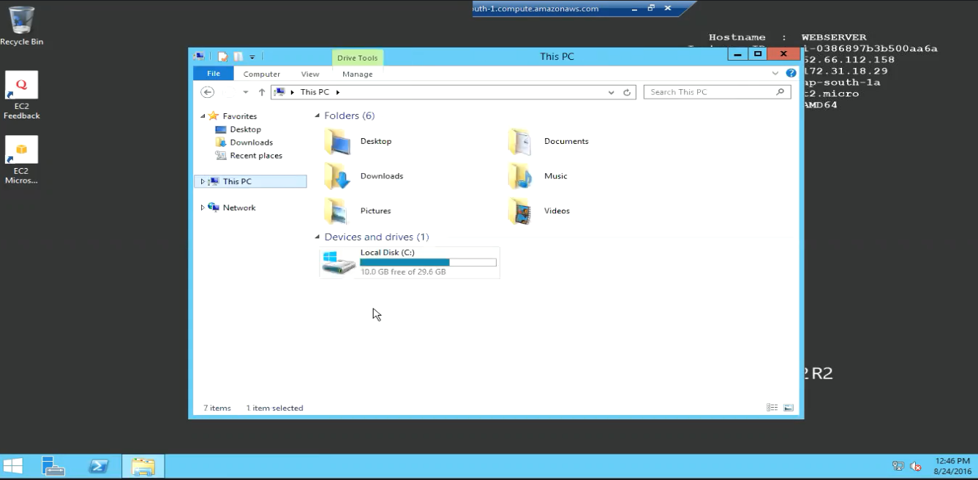

SNAPSHOT CREATED WITH 30GB

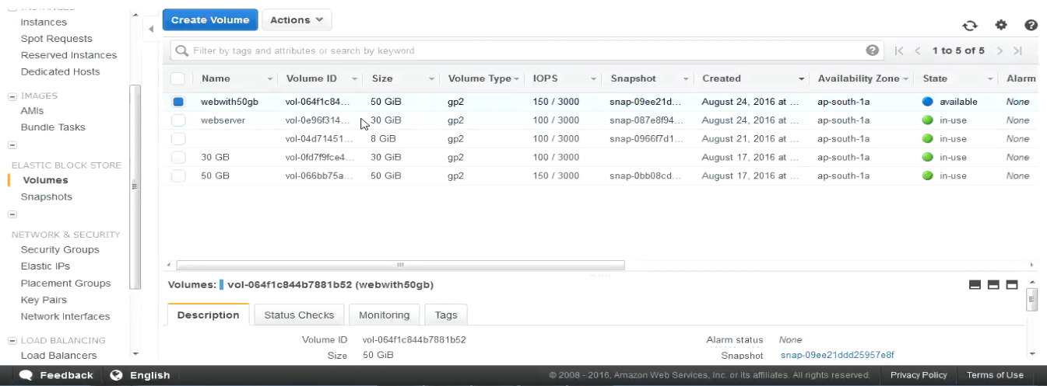

ROOT VOLUME WITH 50GB

